PROJECT SITE SIGN QR CODE
The QR Code is used in the design of the Minnesota State Project Site Sign. Specifications for the sign are found in the Minnesota State Facilities Design Standards in Section IV, Division 1, 01 58 00, Temporary Project Signage. The QR Code is linked to the Capital Improvement Project Summary, which contains a summary description and status of the current Projects. The A/E shall copy the CR Code and paste it to the Project Site Sign graphics. After award of the construction contract, the A/E shall provide the sign graphics to the Contractor for procurement of the Project Site Sign.
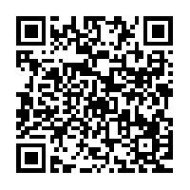
QR CODE

